# CS 255 System Design Document Template

## UML Diagrams

### UML Use Case Diagram

### UML Activity Diagrams

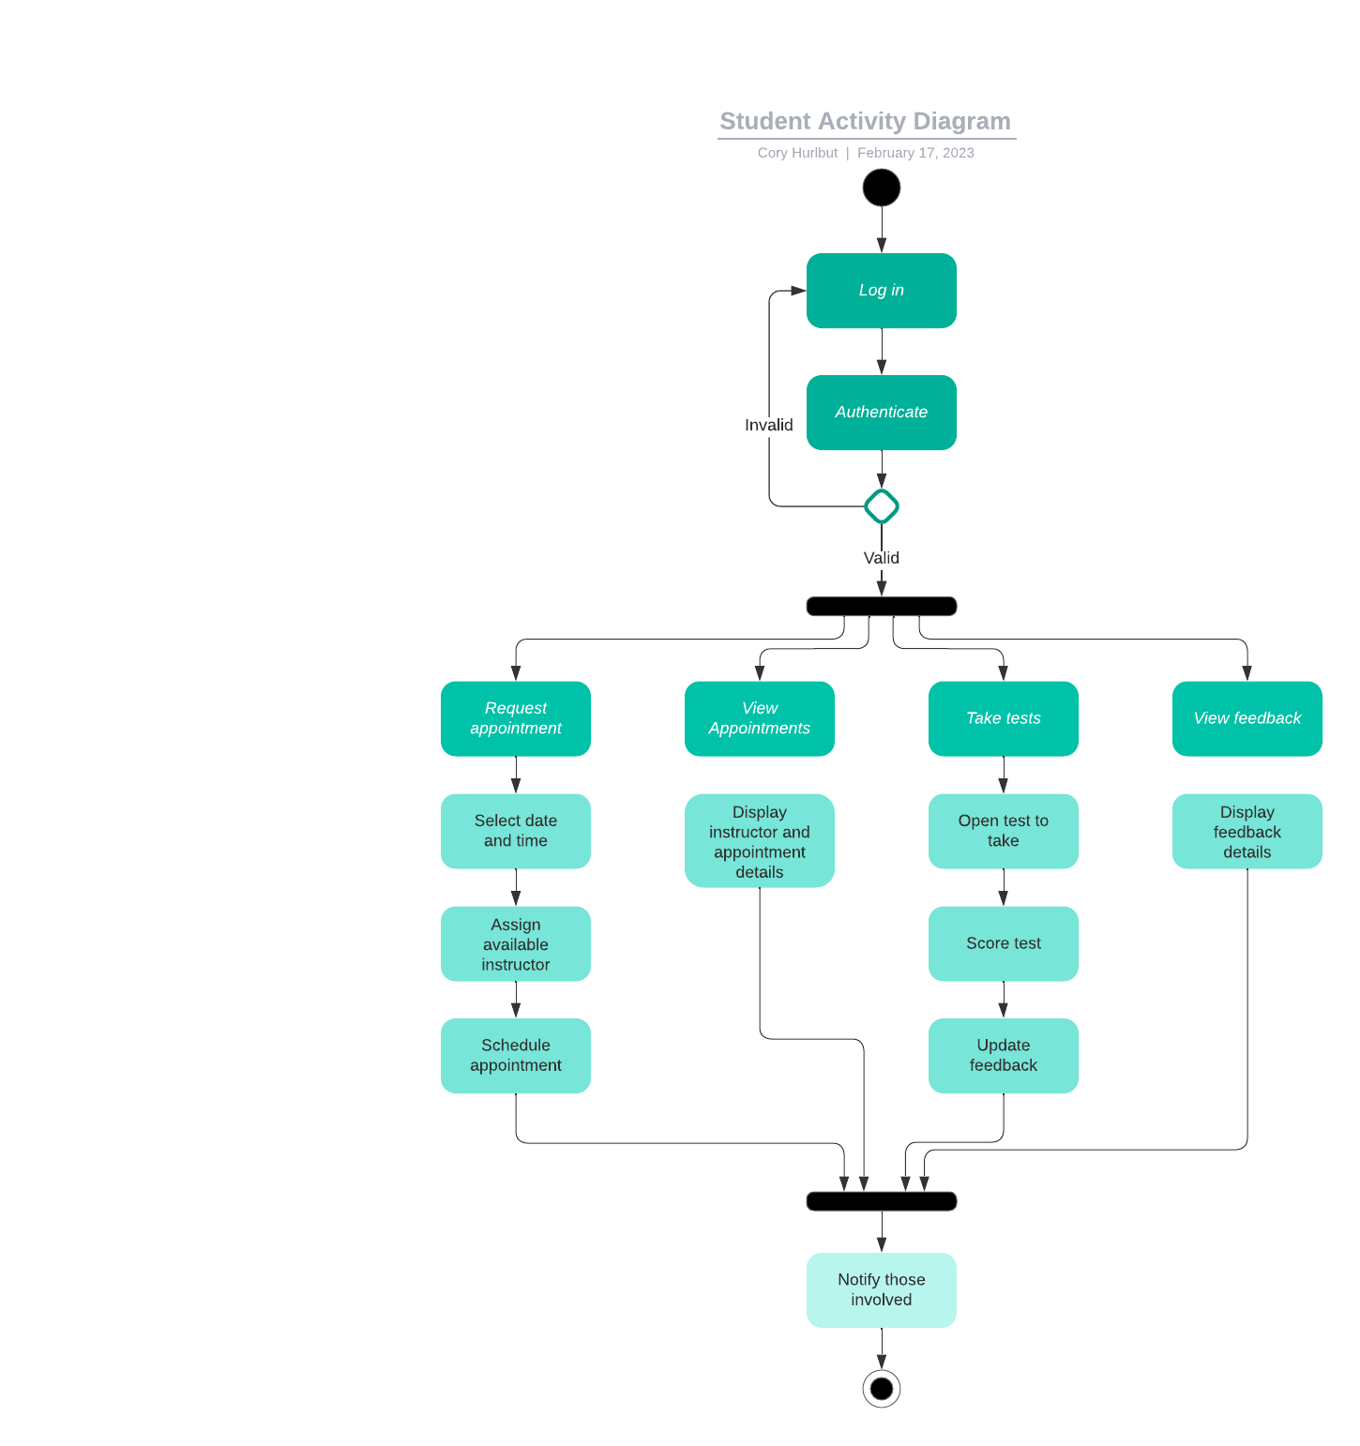

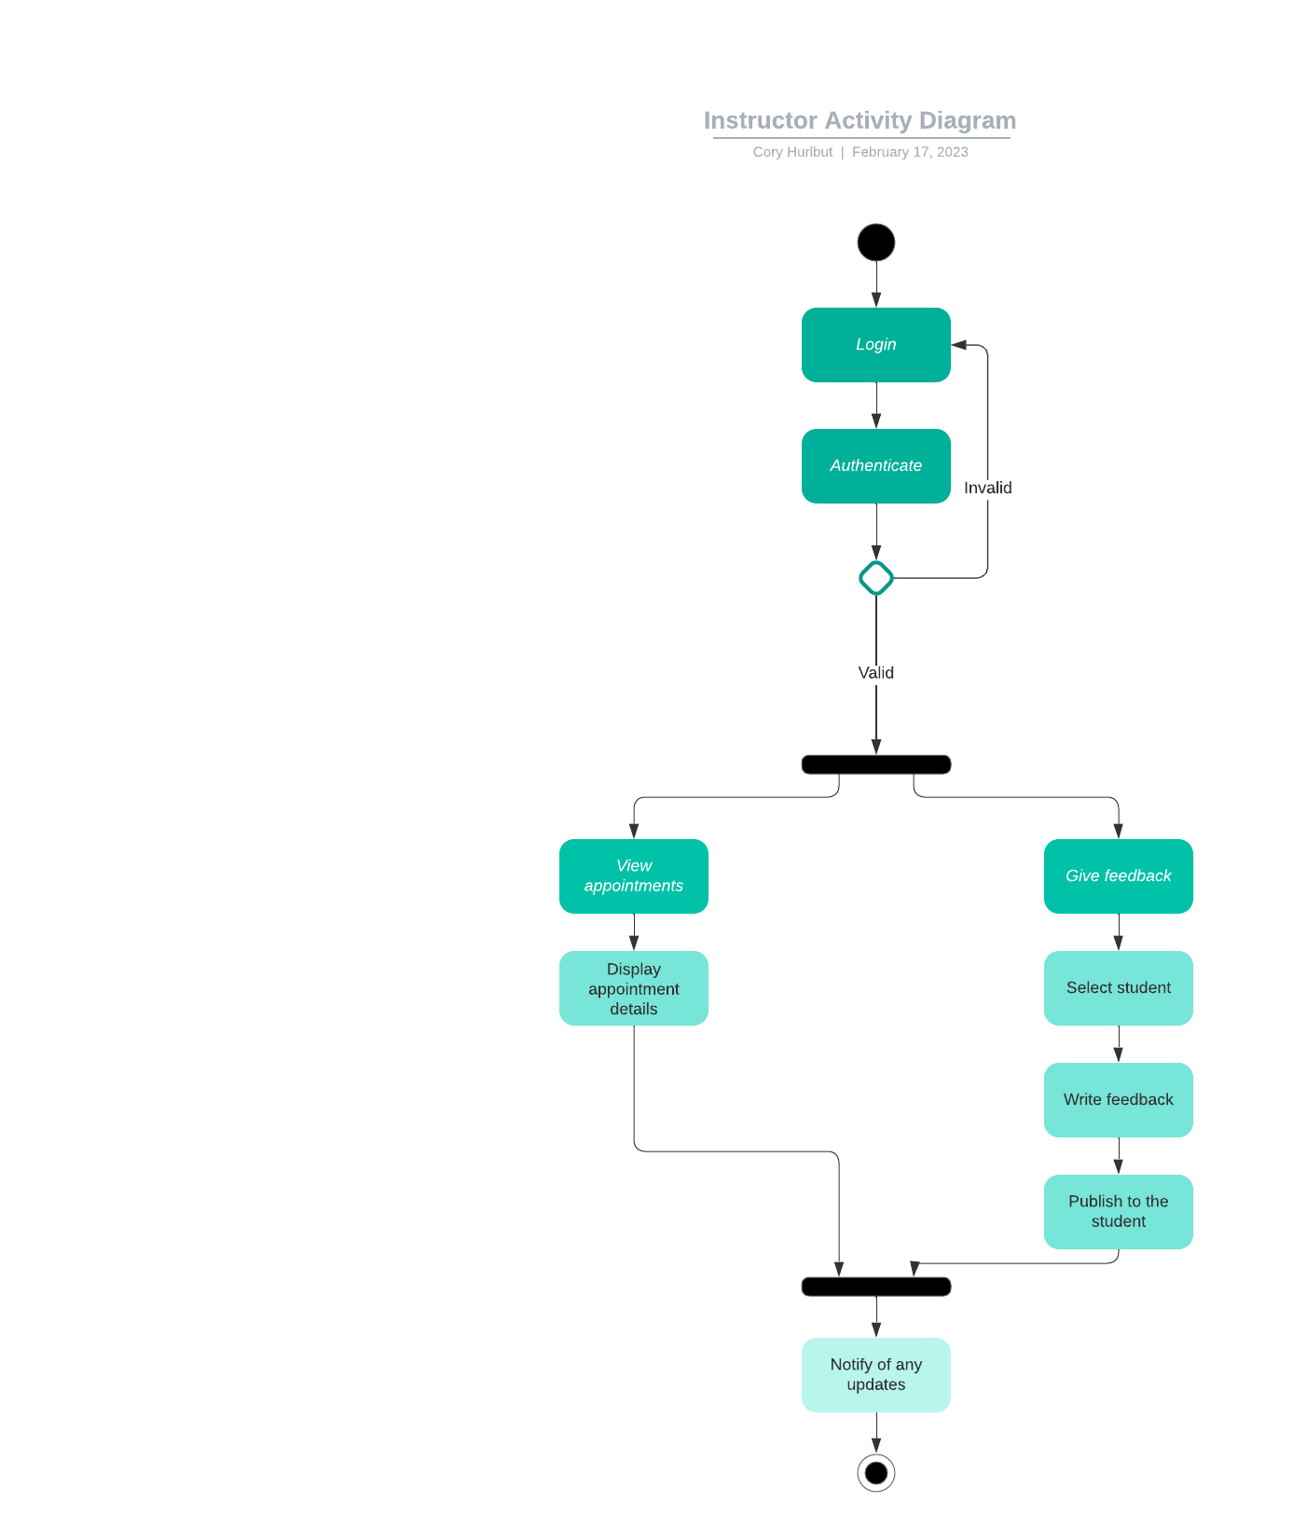

### UML Sequence Diagram

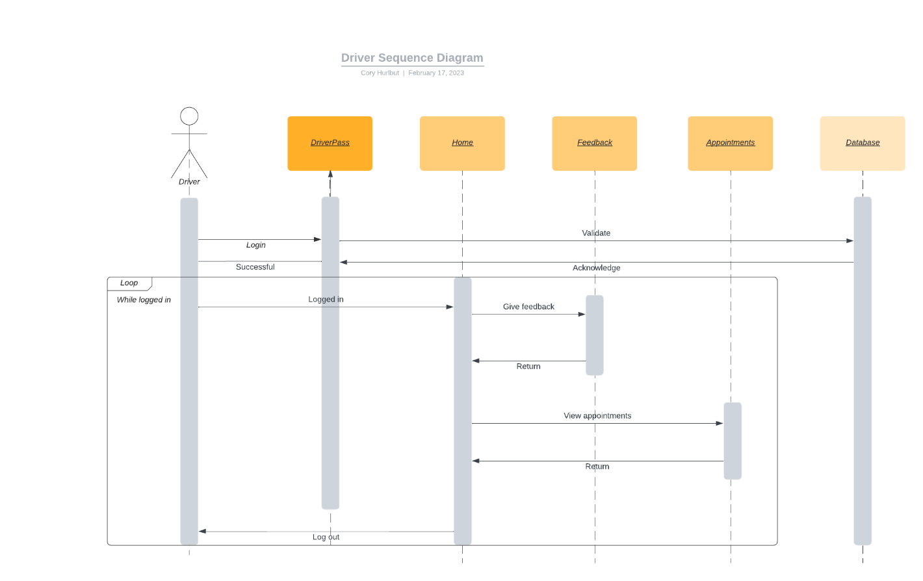

### UML Class Diagram

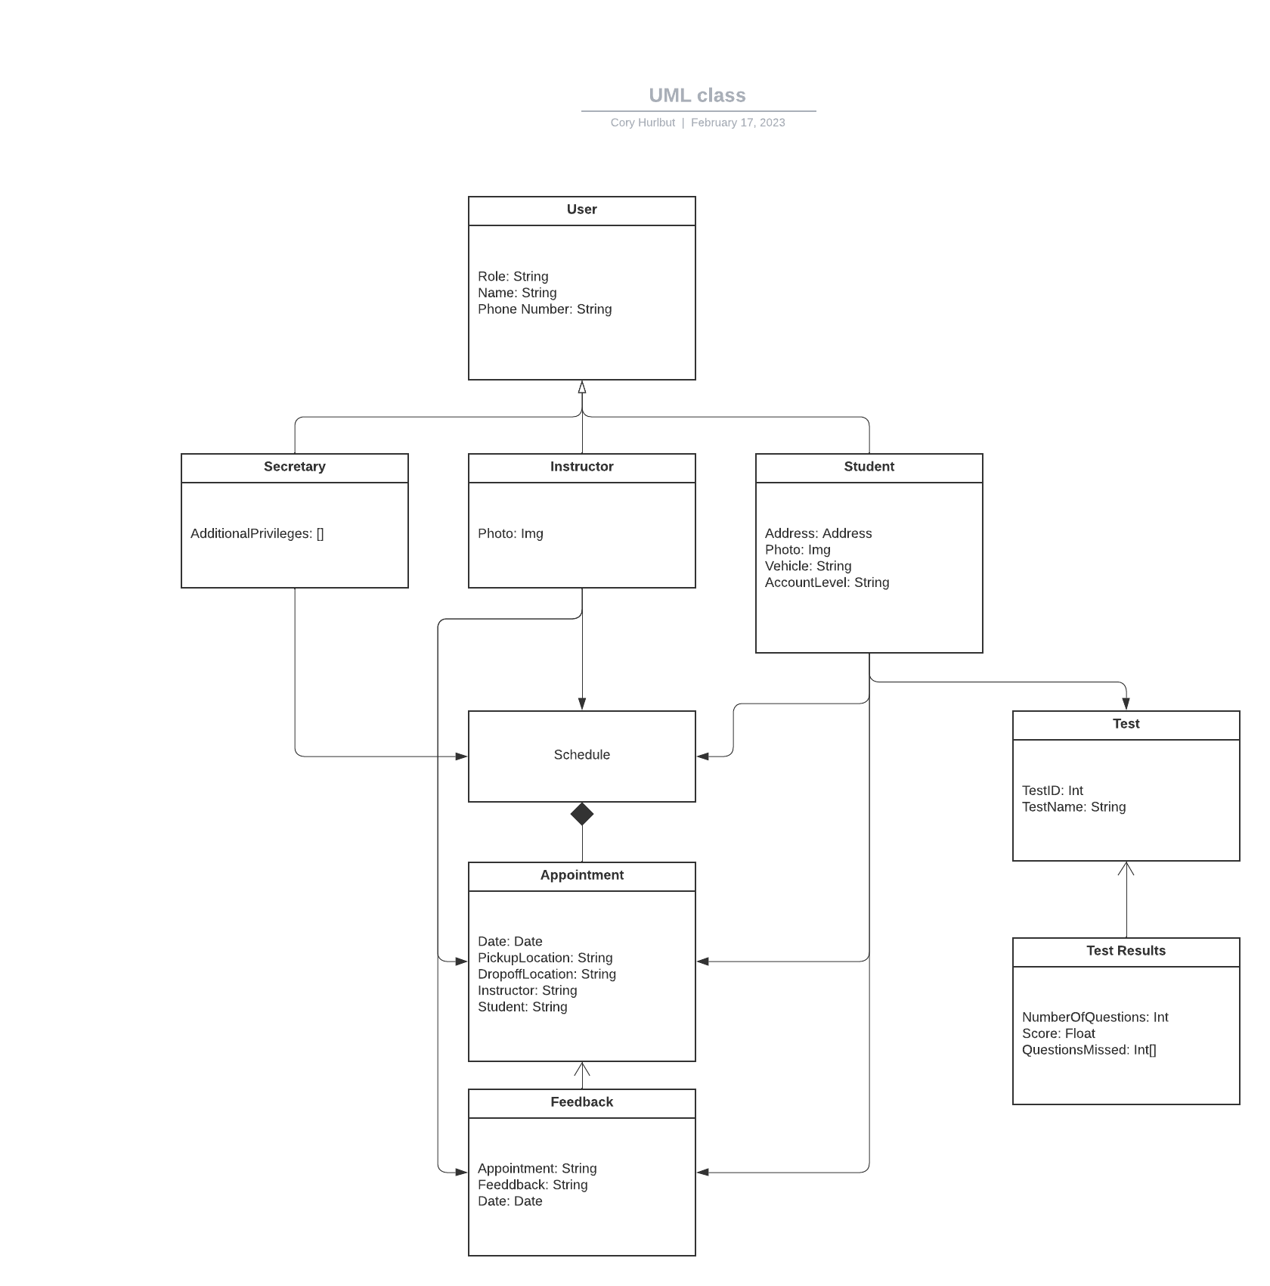

## Technical Requirements

The hardware required for this system will be the computer necessary for the secretary to schedule the appointments and the devices the instructors and students will use to interact with the software. The DriverPass system will be hosted on the cloud. This infrastructure will be rented and maintained by the service provider.